February 1, 2018
INVITATION
Dear Friends,

This year the Quebec Anglophone Heritage Network returns to Quebec City for its 19th Annual Convention and AGM. We've planned an itinerary that we hope you will find exciting and fun, with activities planned over two days on June 9-10, 2018.

Day 1 (Saturday, June 9) includes QAHN's Annual General Meeting. This will take place at the superb Domaine Cataraqui in Quebec's historic Sillery District. The AGM will be followed by networking, a banquet lunch and awards ceremony, and a talk by historian Frédéric Bonin. The visit to Cataraqui will conclude with a guided tour of the Domaine and its interpretation centre. In the evening, a casual supper is planned for anyone who would like to attend, at the Bistro Évolution in Lévis.

On Day 2 (Sunday, June 10) participants will have a chance to get to know Old Quebec a bit better. We'll start off the day with a visit to the Citadelle, a National Historic Site of Canada. This will include a tour of the Regimental Museum and lunch. In the afternoon, we'll embark on a fascinating guided walking tour of the old city. Stops will include some of the capital's most iconic sites: St. Louis Gate; Artillery Park National Historic Site; the Augustine Convent; the Séminaire de Québec; Holy Trinity Cathedral, Château Frontenac; Dufferin Terrace; and Place Royale in Lower Town. Our tour, courtesy of host Simon the Guide, promises to be a lively and memorable one.

So mark these dates in your calendars: June 9-10, 2018!

For more information about the itinerary and fees associated with this event, please consult the enclosed program, registration form and support documents. Participants may pick and choose what they wish to attend, or they can attend everything. All we ask is that you register and return your completed form with payment to QAHN as soon as possible. As space is limited, you should register early. Please note that QAHN has booked a block of rooms for both Friday and Saturday evenings, and at very competitive rates, at the Hôtel l'Oiselière in Lévis. Again, we suggest you book early as space is limited!

We look forward to seeing you in June!
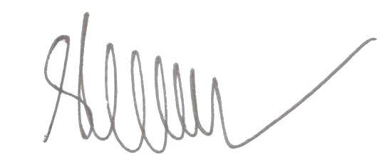
Matthew Farfan
Executive Director

