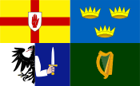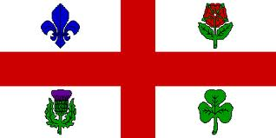
The Federation of Irish Societies
La Fédération des organisations Irlandaises
Cónascadh na gCumann Gaelach
Montreal

Invites you to
The Irishman of the Year Breakfast
Organized by
The Erin Sports Association

Saturday, March 11, 2017, 9:00 a.m.
Plaza Centre Ville (formerly The Delta Hotel)
777 Robert Bourassa (formerly University) Blvd.

Cost: $65.00
(Includes full buffet breakfast and two beverages)
Entertainment: Music by The Melotonz
Two of Montreal’s Top Comedians will be featured

Join Our FIS Table
For tickets contact: Paul Loftus (ploftus@colba.net)
(514) 282-9111
ALL PROCEEDS GO TO CHARITY

