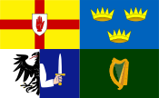he Federation of Irish Societi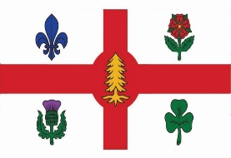
The Federation of Irish Societies
La Fédération des organisations Irlandaises
Cónascadh na gCumann Gaelach
Montreal
“Unity in Our Community”

FIS 5th Annual Christmas Party

Hurley’s Irish Pub
1225 Crescent Street

Monday, December 17, 2018
5:30 p.m.

Music: GAA Musicians
Singing: Christmas Carols with Carol McCormick
MC: Paul Loftus, Chairman
Happy Hour Prices and Complimentary Finger Food

