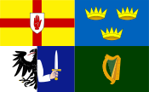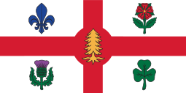
The Federation of Irish Societies
La Fédération des organisations Irlandaises
Cónascadh na gCumann Gaelach
Montreal

Invites You to
St. Patrick’s Day Annual Luncheon

Organized by
St. Patrick’s Society of Montreal

Friday, March 15, 2019, 12:00 noon
(Cash bar: 11:00 a.m.)

Le Centre Sheraton
1201 René Lévesque Blvd. West

Cost: $95.00 (Members of SPS $85.00)
Guest Speaker: The Right Honourable Brian Mulroney, Former Prime Minister of Canada (Introduced by Jean Charest, Former Premier of Quebec and Deputy Prime Minister of Canada)

Join Our FIS Table
For tickets contact: Paul Loftus (ploftus@colba.net) / (514) 282-9111

