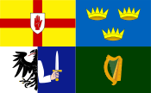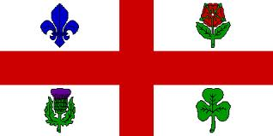
The Federation of Irish Societies
La Fédération des organisations Irlandaises
Cónascadh na gCumann Gaelach
Montreal

Invites You to
St. Patrick’s Day Annual Luncheon

Organized by
St. Patrick’s Society of Montreal

Friday, March 17, 2017, 12:00 noon
(Cash bar: 11:00 a.m.)

Plaza Centre Ville-EVO
777 Robert Bourassa (University)

Cost: $95.00

Guest Speaker: John Rae, Vice President, Power Corporation (Introduced by Bob Rae, former MP for Toronto Centre) St. Patrick’s Society Community Award: Lisa Forget

Join Our FIS Table
For tickets contact: Paul Loftus (ploftus@colba.net)
(514) 282-9111

